Project Documentation

# 1. Introduction

• Project Title: FitFlex

• Team ID: NM2025TMID28783

• Team Leader: [A.Ragaviya] - [ragaviya7@gmail.com]

• Team Members:

– [S.Harini] - [roshanharini0318@gmail.com]

– [K.Atchaya] - [atchayaatchaya3209@gmail.com]

-[D.Yogeshwari] - [yogakarthika2002@gmail.com]

# 2. Project Overview

• Purpose: FitFlex is a fitness tracking and workout management platform that allows users to create personalized workout routines, monitor progress, and stay motivated with interactive tools.

• Features:

– User registration and login

– Workout routine creation and customization

– Progress tracking dashboard

– Admin panel for managing users and content

– Responsive UI for mobile and desktop

# 3. Architecture

• Frontend: React.js with TailwindCSS and Bootstrap

• Backend: Node.js and Express.js managing server logic and API endpoints

• Database: MongoDB stores user data, workouts, and progress reports

# 4. Setup Instructions

• Prerequisites: Node.js, MongoDB, Git, VS Code

• Installation Steps:

# Clone the repository  
 git clone <repo_url>  
 cd fitflex

# Install client dependencies  
 cd client  
 npm install

# Install server dependencies  
 cd ../server  
 npm install

# 5. Folder Structure

FitFlex/  
|-- client/ # React frontend  
| |-- components/  
| |-- pages/  
|-- server/ # Node.js backend  
| |-- routes/  
| |-- models/  
| |-- controllers/  
|-- package.json  
|-- README.md

# 6. Running the Application

• Frontend:  
 cd client  
 npm start

• Backend:  
 cd server  
 npm start

• Access: Visit http://localhost:3000

# 7. API Documentation

• User:  
 – /api/user/register  
 – /api/user/login

• Workouts:  
 – /api/workouts/create  
 – /api/workouts/:id

• Progress:  
 – /api/progress/update  
 – /api/progress/:userId

# 8. Authentication

• JWT-based authentication for secure login

• Middleware protects private routes

# 9. User Interface

• Landing Page

• User Dashboard

• Admin Panel

• Workout Details Page

# 10. Testing

• Manual testing performed during milestones

• Tools: Postman, Chrome Dev Tools

# 11.Screenshots or Demo

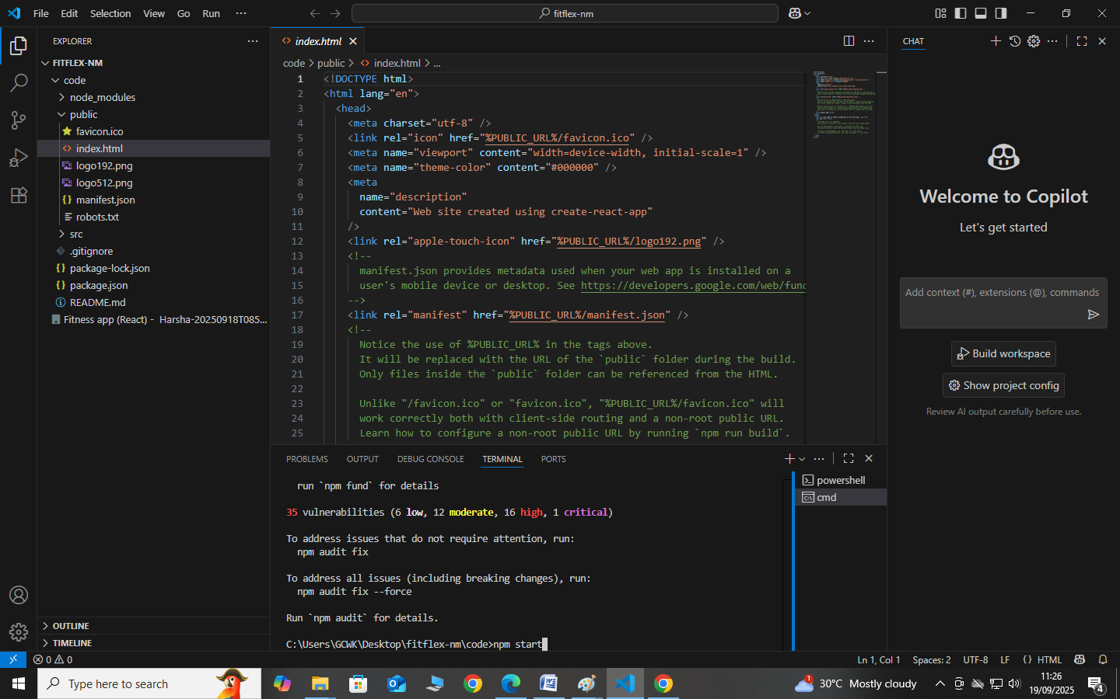

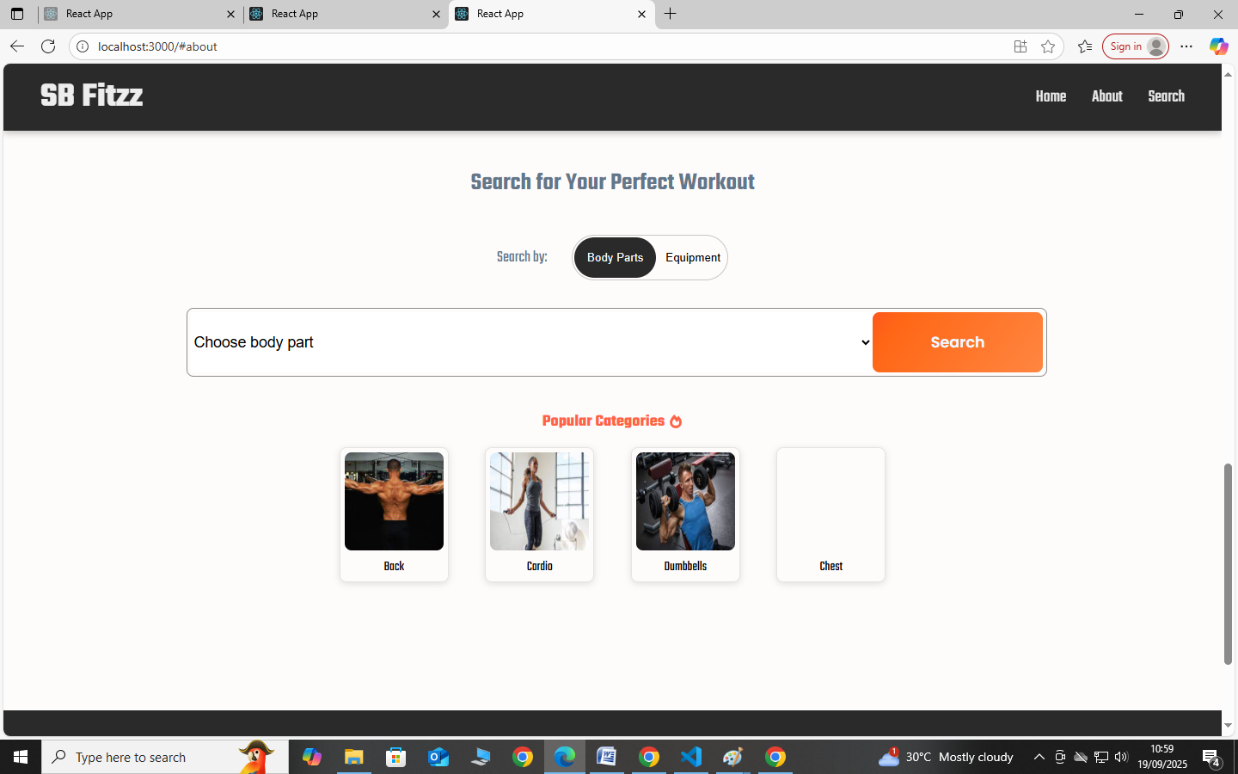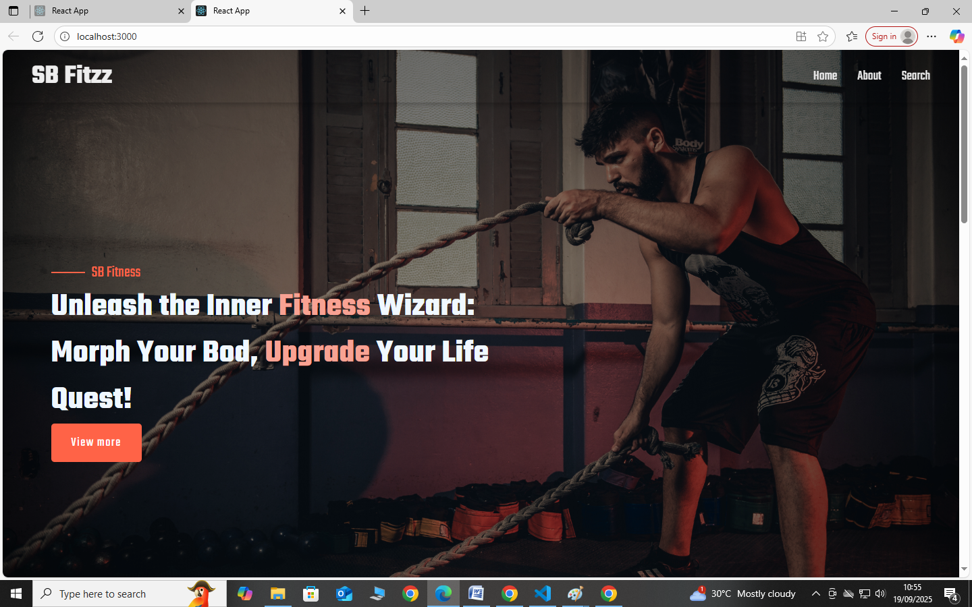

# 12. Known Issues

• Limited analytics features

• No integration with third-party fitness APIs yet

# 13. Future Enhancements

• Integration with wearable devices and fitness APIs

• AI-based personalized workout suggestions

• Social sharing features